ARM Template for Deploying Azure AD Connect

Prepared by: Gang Pan

AcutePath, Inc.

# Introduction

This document describes how to use Azure Resource Manager Template to deploy a new virtual machine in Azure, and join an existing Active Directory domain provisioned in Azure. And automatically install Azure AD Connect on the provisioned virtual machine.

# Description of ARM Template

The ARM template assumes there is an existing virtual network has been provisioned in Azure, and the virtual network contains an existing Active Directory domain controller either thru site-site VPN or within the same Azure virtual network.

The ARM template requires the following input parameters:

|  |  |
| --- | --- |
| **Parameter Name** | **Description** |
| existingVNETName | Existing VNET that contains the domain controller |
| existingSubnetName | Existing subnet that virtual machine will be deployed, the subnet should be able to connect to domain controller |
| dnsServerPrivateIP | The private IP address of the DNS server of the Active Directory Domain to resolve the domain controller |
| vmName | The name of the virtual machine will be deployed |
| vmSize | The virtual machine size |
| domainToJoin | Domain name the virtual machine will join |
| domainUserName | Domain account will be used to join the domain |
| domainPassword | Password of the domain account used for joining the domain |
| ouPath | Organization Unit path will be used for joining the domain |
| domainJoinOptions | Set of bit flags that define the join options. Default value of 3 is a combination of NETSETUP_JOIN_DOMAIN (0x00000001) & NETSETUP_ACCT_CREATE (0x00000002) i.e. will join the domain and create the account on the domain. For more information see <https://msdn.microsoft.com/en-us/library/aa392154(v=vs.85).aspx> |
| vmAdminUserName | Local admin user name for the virtual machine |
| vmAdminPassword | Password of the local admin user account for the virtual machine |
| imageSKU | Windows Server SKU |
| _artifactsLocation | The base URI where artifacts required by this template are located |
| _artifactsLocationSasToken | The sasToken required to access _artifactsLocation |

# Deploy Guide

You can upload the ARM template and associated script to a private azure storage account or a public accessible web location, such as github repository.

To deploy the template, you can use Azure Portal which will automatically generate a UI based on the parameters defined in the template to deploy as shown below:

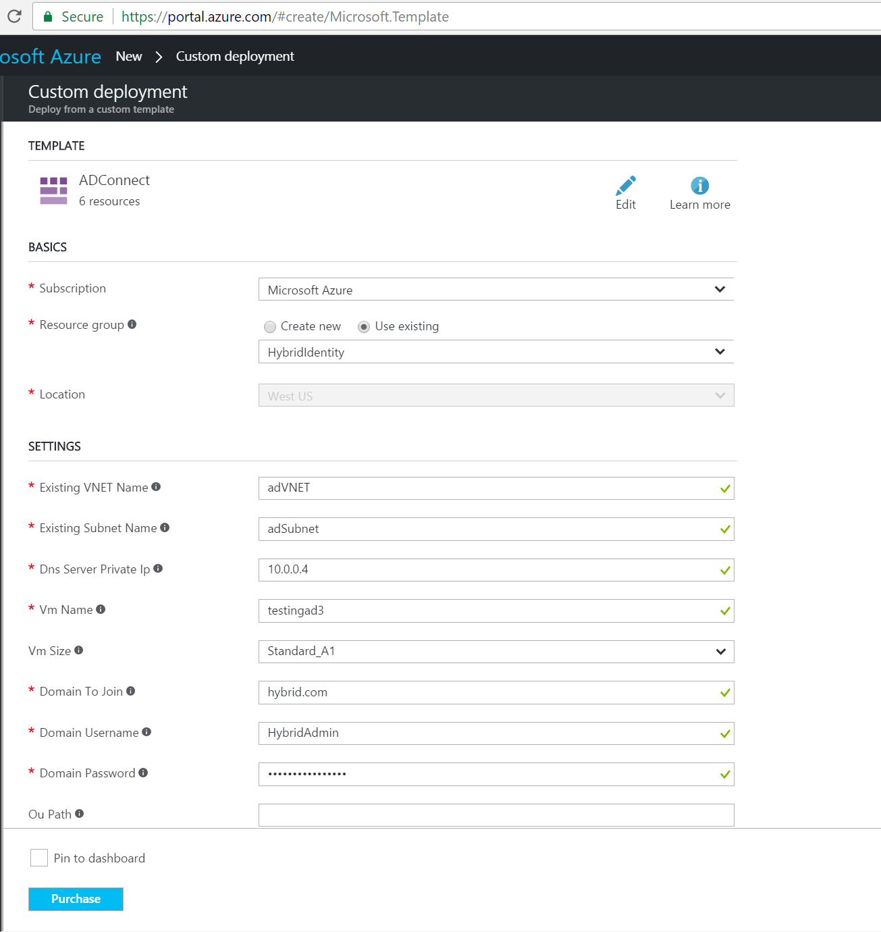

Once you fill out the form with the appropriate values, click “Purchase” button will start the deployment. You can monitor the deployment progress in Azure Portal as shown below.

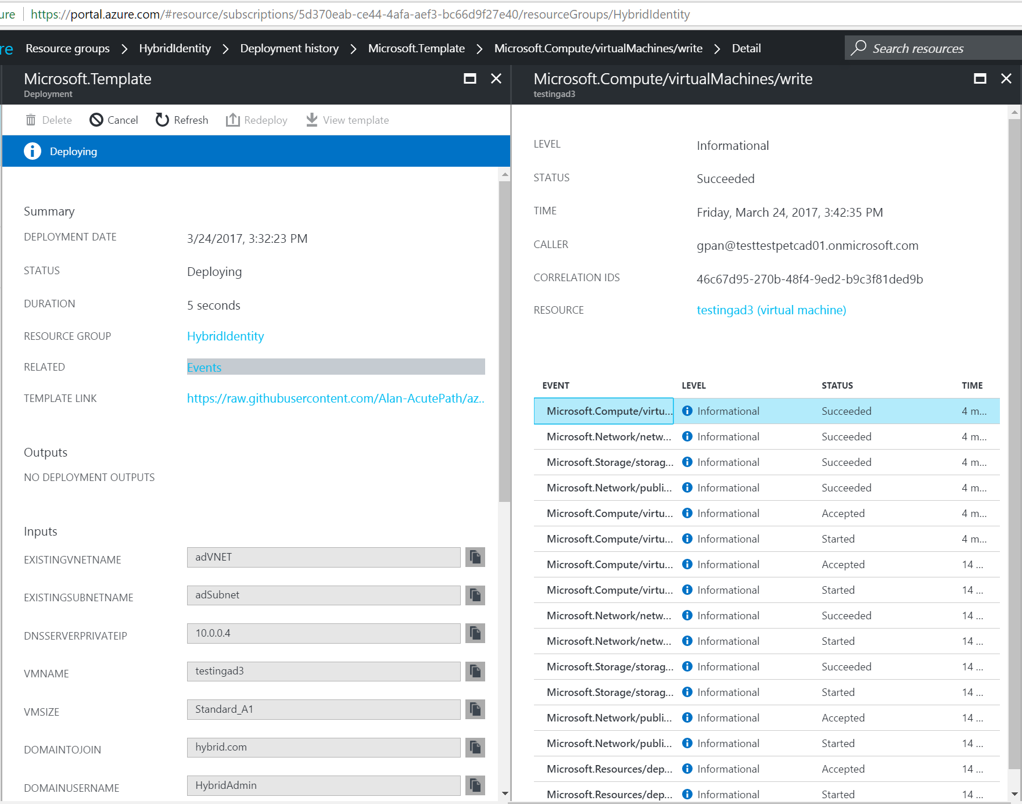

Once the deployment is completed successfully, you can connect to the provisioned virtual machine by clicking Connect button in Azure Portal, it will download the rdp file to connect to the virtual machine as shown below.

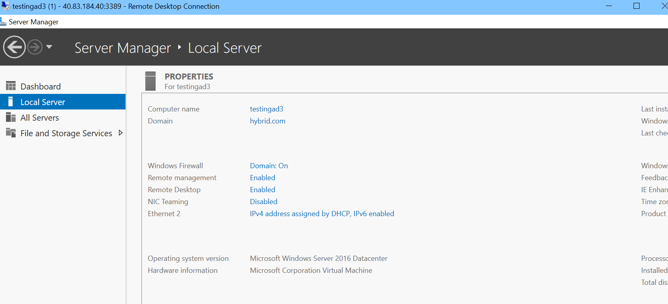

As shown below, the virtual machine is automatically joined into the given domain, and Azure AD Connect is also automatically installed.



